|  |
| --- |
| Manshur Ramhith |

Humber College Institute of Technology & Advanced Learning DeepRacer Entry 0NB

Status

/1 Hardware present?

/1 Title Page

/1 Declaration of Joint Authorship

/1 Proposal (500 words)

/1 Executive Summary

# Declaration of Joint Authorship

We, Manshur Ramhith, Deval Rajgor, and Abdirashid Yusuf, confirm that this work submitted is the joint work of our group and is expressed our own words. Any uses made within it of the works of any other author, in any form are properly acknowledged at the point of use. From the previous semester each one of us worked individually on our hardware but also, we had to build an APP in CENG319 by working as a group. Thus far, I would say that each and every one of us has been the lead on our own hardware. Therefore, Manshur has worked on the temperature & humidity Sensor, Deval worked on a combination of the luminosity Sensor and the Neopixel Ring and Abdirashid has focused on the audio part by working on the microphone sensor. However, for the software part, we all worked as a group to put together a mobile application which covered the main features that our final project is going to have. For the software, Manshur worked with the database(input & retrieve from it) as well as graphs that display the change in temperature and humidity levels, Deval implemented a color wheel, a feature that is going to be useful for the neopixel ring and Abdirashid worked on the Bluetooth part of our APP(which is needed for the communication). I would also say that we all equally on designing the APP as a whole and the aesthetic aspect of the piece of software.

# Proposal

In one of our previous course CENG319(Software Project), we have created a mobile application that allowed us to work with databases by manually putting data into the database to simulate real time data and retrieve this data at any given time. In CENG 317(Hardware Project), we have prototyped a small embedded system with a custom PCB as well as an enclosure which held our individual Sensor and development platform (mine was both 3D printed & laser cut). In this semester our main aim is to make the hardware and software part work in parallel in order to have a fully functioning model.

Below is a list of the components that we are using:

Development platform: Broadcom Development platform (Raspberry Pi 3B+/4)

Sensor/Effector 1: DHT 22 (Temperature & Humidity Sensor)

Sensor/Effector 2: TSL 2591 (Luminosity Sensor)/ Neopixel Ring

Sensor/Effector 3: SPH 0645LM4H (Microphone Sensor)

Our project will include the use a microphone to detect any noise coming from the room & mainly a temperature and humidity sensor, we also plan on adding a full-duplex communication line for the parents to hear and talk to their kids and maybe also an option that alerts the parents of the condition in the room depending on the temperature and humidity. Moreover, we will have a luminosity sensor that will work with a Neopixel Ring to create an ambiance inside the infant’s room whenever the luminosity level drops below a certain set point. This application will help a lot of parents understand their babies’ needs and will also retrieve the optimum conditions in which the baby has a better sleep. More specifically, the screen of the application will be displaying temperature Degrees Celsius and humidity percentage at any given moment, an open line access to the microphone which will be always on as well as an option to manually set the colors of the Neopixel ring if wanted.

In this semester, we hope to achieve the goal of our Internet of Things (IoT) capstone project that will use a distributed computing model of a smart phone application, a database accessible via the internet, an enterprise wireless (capable of storing certificates) connected embedded system. We also plan to design a new prototype with a new custom PCB as well as an enclosure that will successfully hold the whole of our integrated portable system.

Our physical prototype that we intend to build is to be small and safe enough to be brought to class every week as well as be worked on at home. In alignment with the space below the tray in the Humber North Campus Electronics Parts kit the overall project maximum dimensions are 12 13/16" x 6" x 2 7/8" = 32.5cm x 15.25cm x 7.25cm.

# Executive Summary

This app combines all the functionalities of light, temperature/humidity and sound to ensure that parents have absolute control over the conditions in which their babies are living in. The app has been tested with sample data at the moment from firebase. However, for this semester, we plan on implementing the sensors with the app to get the data directly from them which will put the readings into the database. Moreover, as we already have the Bluetooth connection working, we only have to send the voice over the channel as a part of this semester’s implementation. I feel that our APP will revolutionize the realm of baby monitors because as of today I don’t think that there is any product currently available with the features that we are offering. I also feel that our product will attract a large range of customers as they will be able to keep track of the perfect conditions for their babies to sleep in and stay comfortable.

Contents

Declaration of Joint Authorship 3

Proposal 5

Executive Summary 6

List of Figures 11

1.0 Introduction 13

1.1 Scope and Requirements 14

2.0 Background 17

3.0 Methodology 19

3.1 Required Resources 19

3.1.1 Parts, Components, Materials 19

3.1.2 Manufacturing 21

3.1.3 Tools and Facilities 22

3.1.4 Shipping, duty, taxes 24

3.1.5 Time expenditure 25

3.2 Development Platform 27

3.2.1 Mobile Application 27

3.2.2 Image/firmware 32

3.2.3 Breadboard/Independent PCBs 33

3.2.4 Printed Circuit Board 42

3.2.5 Enclosure 45

3.3 Integration 46

3.3.1 Enterprise Wireless Connectivity 46

3.3.2 Database Configuration 47

3.3.3 Security 47

3.3.4 Testing 47

4.0 Results and Discussions 49

5.0 Conclusions 51

6.0 References 53

7.0 Appendix 55

7.1 Firmware code 57

7.2 Application code 57

# List of Figures

Figure 1. By Android Studio – App Demo on Emulator 30

Figure 2. By Android Studio – Data Visualization on Emulator. 31

Figure 3 – Breadboard Design for DHT22 36

Figure 4 - PCB design for DHT22 37

Figure 5 - Schematic for SPH0645 37

Figure 6 - PCB Design for SPH0645 38

Figure 7 - Schematic Design for TSL2591 and Neopixel Strip 38

Figure 8 - PCB Design for TSL2591 and Neopixel Strip 39

Figure 9 - Final Breadboard Connection for DHT22 39

Figure 10 - Final Breadboard Connection for SPH0645 40

Figure 11 - Breadboarded Connection for TSL2591 & Neopixel Strip 40

Figure 12 - PCB for DHT22 41

Figure 13 - PCB for SPH0645 41

Figure 14 - PCB for TSL2591 & Neopixel Strip 42

Figure 15 Complete and soldered PCB 43

Figure 16 Final PCB design Lumi 43

# 1.0 Introduction

The Lumi monitor is designed to help young and overwhelmed parents by easing the hardships of parenting. With the use of a simple GUI, the aim for our application will be to enable parents to pay attention to their baby via a hardware installed in a baby’s room which will include two-way audio communication, sensors that track room temperature and humidity as well as a light and luminosity control. The Lumi monitor allows parents to monitor and understand their baby’s daily development around the clock. Our product can be viewed as an ameliorated approach on baby monitors and will definitely revolutionize the realm of baby monitors as we are not only implementing a voice channel like most baby monitors but also a way of keeping track of the perfect conditions for babies to sleep in and stay comfortable. Our project will target three major issues which are:

• Adjusting the appropriate living conditions inside the baby’s room. (Temp & Humidity)

• Setting an appropriate theme in the baby’s room.

• Communication.

The intent of this APP is to ease the life of parents by keeping track of the living conditions of their infants and ensuring the safety and comfort of their baby through the installation of an integrated hardware in the baby’s room. In this project we will use three sensors and one effector namely: Tsl2591(light sensor) along with a Neopixel ring (LED strip), DHT22 (temperature & Humidity), SPH0645LM4H (Microphone). This project is unique since it allows parents to use a variety of functionalities through an Android app with a friendly User interface. The main development platform that we will use to implement the project is the Raspberry pi. The purpose of this project is to make the life of parents as easy as possible as well as convenience and ease of access to vital information for parents about their babies. With the help of our application, parents will be able to get access to a history of the levels of temperature and humidity for a set amount of days. This information as well as a bunch of other relevant ones will be stored on a database which will be automatically updated using our sensors. Communication will also be possible as the hardware installed in a baby’s room which will include two-way audio communication interface. Moreover, with light and luminosity control from within our APP, parents will be able to adjust the lighting of the room to their liking. Therefore, our product can be viewed as an ameliorated approach on baby monitors and one of the most advanced baby monitors as we are not only implementing a voice channel like most baby monitors but also a way of keeping track of the perfect conditions for babies to sleep in and stay comfortable. It is therefore safe to say that the Lumi monitor allows parents to not only monitor and understand their baby’s development around the clock but also customize parts of this process to their liking. In the scope & requirements section, we will cover what we need in order to complete this project and also what need to be changed from what we already have.

## 1.1 Scope and Requirements

Currently we have the hardware and the software apart. The project prototype is connected embedded system prototype with a custom PCB as well as an enclosure 3D printed. We will connect three sensors to a single PI. With this connection to the Raspberry Pi, we would implement code that would allow a connection to our real-time database and upload the data of each sensor to its corresponding heading of the data structure. With this data uploaded, it would allow for real-time retrieval within the application that would show the changes through time. The data that would be retrieved from our sensors would be the Temperature & Humidity (Acquired by DHT22), the Light Level (Acquired by TSL2591). The other sensor that we plan to implement in our project is the microphone (SPC0645). However, for this sensor, the connection will be done through Bluetooth and therefore not require a spot in the database. As for our effector the Neopixel Ring, the data will be chosen and coming from the user of the APP as compared to the sensors. We are not considering to take the project to CSA for testing because it is only for course completion and graduation purposes only.

# 2.0 Background

We would like to thank mentor Diego Magalhães from AWS for supporting this project. This section is to include at least three references, here is an example of an APA citation of a website (OACETT, 2017) followed by a sentence citing an Article in a Periodical, a Book, and a Journal Article. Humber is planning to host an internal DeepRacer event using an existing example of machine learning (Robuck, 2018), artificial intelligence (Media, O., 2019), and internet connected servers (Kinsella, 2019).

# 3.0 Methodology

This Section will discuss how we plan on implementing our project by making use of various facilities, tools and materials. It will also cover how we plan on purchasing any new parts required to reach the ultimate goal of this project. An idea of our planned time expenditure is also given in this section.

## 3.1 Required Resources

Report

/1 Parts/components/materials (500 words)

/1 PCB, case (500 words)

/1 Tools, facilities (500 words)

/1 Shipping, duty, taxes (250 words)

/1 Working time versus lead time (250 words)

### 3.1.1 Parts, Components, Materials

In this project we will use a variety of materials and components to make it work successfully. This section will discuss the assembly of newly acquired and already available products from the past semester. The most important components in the project includes the sensors namely: Light & Luminosity (Tsl2591), Temperature & Humidity (DHT22), and Microphone (SPH0645LMH). Deval is working with Raspberry Pi 4 model b. His part of the project includes various components, like the SN74AH125 convert chip used in the circuit to convert 3.3v to 5v for the Neopixel ring to get the appropriate voltage. He further has the WS2812B Neopixel ring to accompany the sensor in measuring the temperature and based on those values lighting up the individually addressable LEDs. The next component in his project is the 40 male to female jumper wires to connect the female side from the Pi pins to the sensor’s pins on the breadboard. He also used the 5v DC power adapter to provide external power to his Neopixel Led ring. Furthermore, in order to connect the 5v DC power adapter to the breadboard, he used the DC female power connector that lets you connect the DC adapter to breadboard. He integrated all these individual components into an epoxy resin PCB board along with a black project enclosure. Manshur was working on the Dht22 temperature sensor and is working on the raspberry pi 3 model b+. He has a case that is acrylic on the top and 3D printed at the bottom enclosing his development platform. He also has the 20 male to female jumper pins to connect from the raspberry Pi to the breadboard for the testing phase of last semester’s work. Later he designed a printed circuit board using fritzing software and sent his design to the Humber college prototype lab in the north campus for manufacturing. Abdirashid has been working on I2S Microphone Breakout sensor SPH0645LM4H (Broadcom) throughout last semester. Similar to Manshur, he has been using raspberry pi 3 B+ as his development platform. He has got a printed circuit board that connects the sensor to the development platform instead of having to use male to female jumper wires for connection. For this semester our aim is to have a single printed circuit board on a single development platform (Raspberry pi) that is connected to all the sensors and effector, along with the single case (Materials to be used: acrylic & Polyamide for 3D printing and or plastic) to finalize the project prototype. We further hope to send the final PCB design designed through the fritzing software to a PCB manufacturer such as the one located in Humber college’s prototype room. Going ahead with this semester we have knowledge from the previous semester, and we are quite familiar with the resources available to us here at Humber college. During the development of this project, we recognize that there will be frequent problems with the PCB, casing, or other materials used and we wish to make changes accordingly through troubleshooting experience gained from last semester. We intend to utilize these resources to complete the final project prototype.

### 3.1.2 Manufacturing

The final prototype is required to be enclosed in a case with a printed circuit board connecting the sensors to the raspberry pi instead jumper wires. Therefore, we took time to design printed circuit board and both 3D printed and laser cut cases in hardware production technology class last semester with help of professor Kristian Medri. We have used the fritzing software for designing printed circuit board and sent the final design to the Humber college prototype lab where it took at least a day to produce the board. However, it took some of us more than one attempt to design a working PCB. My first attempt was not successful because I had misplaced some wires in the design. My second attempt was good but I had soldered my sensor on the wrong side of the board. Finally, I learnt from my first two mistakes and produced a working PCB. It also took my colleagues several attempts to get a final PCB board. Since we have separate board for all sensors, we planning to design a final printed circuit board that takes all the sensors and connects them to the development platform (raspberry pi) instead of stacking three PCBs each holding a specific sensor. This will make the final prototype simple and organized. Before we designed a case last semester, the professor took us to the Humber idea lab so that we can see how to 3D print. Similar to the printed circuit board, the casings were not perfect after the first attempt of designing enclosure. The school 3D printer was not capable of accommodating many students at once. Therefore, it was hard to print your design within a day. Also, it took average of two hours to print a single part of the design. As a result, Manshur print only the lower part of his case from the idea lab. The second option was to design an acrylic enclosure using a software called Corel draw. This design would be sent to the Humber college prototype lab where design is printed and laser cut. This option was much faster than 3D printing since it only took an average of ten minutes. Abdirashid and Deval both printed their casings at the prototype lab and Manshur printed his top part of the enclosure here. This semester we expect it to be much easier when it comes to making a printed circuit board and case for the final prototype because we have got valuable experience from last semester.

We have created several casings in the hardware class last semester but we are thinking of making a new design for the final prototype. For example, we are going to have an acrylic panel that is translucent in order to hide the LEDs of the neopixel from the human eye, but also to let the light set by the user shine through the room whenever turned on. Furthermore, our case has to be well ventilated as it will hold a temperature and humidity sensor which will be affected by heat generated by the hardware itself.

### 3.1.3 Tools and Facilities

In this segment, we will be discussing what tools/ facilities that we intend to use in order to achieve our final goal for this project. First of all, a vast majority of facilities are available for us here on campus at Humber College North Campus. As you already know, we are going to have to design a new case and a new printed circuit board for our final project. We intend on using the services that are available here at Humber in order to do so. As we are already familiar with these facilities available here having used them in order to complete our Hardware Project course last semester, we hope that having to use them again this semester will be much easier. To begin with, the case will be designed using a special piece of software called Corel Draw which will help us save time whenever we design our acrylic enclosure. After designing our desired acrylic piece, we will have to get the latter printed in the prototype Lab using a special printer/laser cutter found in J233. Moreover, as per the requirement, we are supposed to also have a 3D printed piece of the enclosure. This will once again imply using the tools and facilities that we are already familiar with. For last semester’s project, I designed the bottom part of my enclosure and got it printed using the 3D printer at the “Idea Lab” found on the 3rd floor of the Learning Resource Commons here at Humber College. For this semester, we plan on doing the same but this time our design will hopefully be different as we are combining our 3 individual projects into one, which will require a more sophisticated case.

As for the Printed circuit board, we will have to design a new one which will accommodate our three sensors and one effector. In order to achieve this goal, the designing process will either be done on Fritzing software or by an online circuit builder. This design will then be tested on our breadboards which are available from our tool kits and same goes for any resistors/capacitors or transistors which will be required to build/test a safe and functioning circuit. Upon successful completion of this task, we will proceed to designing the Printed Circuit Board to replace the breadboarded connection and functionalities. When this step is completed, we will send the required files (Gerber files) to the prototype lab in order to get the PCB printed. We will then proceed to connecting our hardware to the Printed Circuit Board and then to our Development Platform which will be the Broadcom Development Platform also known as the Raspberry Pi. If ever, we are not able to complete one of the above tasks on our own, we are also allowed to involve a third-party company which might help us achieve our goals faster and more efficiently. As for any other physical tool required during testing/development, we believe that our parts kit will contain most of them. Having said all of the above, we still have to keep in mind that our final product has to fit underneath the tray in the Humber North Campus Electronics Parts kit which has the following dimensions 12 13/16" x 6" x 2 7/8" = 32.5cm x 15.25cm x 7.25cm

### 3.1.4 Shipping, duty, taxes

Since the Lumi project needed hardware parts such as, different sensors mainly Microphone Breakout - SPH0645LM4H, TSL2591 Luminosity sensor, DHT22 Temperature and Humidity sensor, Student lab kit and the development platform, Raspberry pi. We shared the responsibility to gather the hardware and make sure the sensors were functioning before we put everything together. Every one of us, Abdirashid, Manshur and Deval was tasked to provide a specific sensor. Abdirashid bought the Microphone Breakout - SPH0645LM4H from the manufacturer that is Adafruit through their website Adafruit.com. the price of the sensor was USD 6.95$. additional 0.90 $ for customs and taxes. Also, Adafruit do not do free shipping. So, I had to pay additional fee USD 19.27 for shipping through DHL world-wide. The total cost of this sensor was USD 27.12, that is CAD 35.74. It took two days to be delivered to my address. Deval bought his sensor, TSL2591 Luminosity sensor from the website of the manufacturer Adafruit.com for 6.95 USD he was also charged 0.90 USD for duty and taxes and 19.27 USD for shipping through DHL world-wide. His total for the sensor was 27.12 USD which is 35.74 CAD. Besides the sensor, He also bought a pack of 20 male to female jumper wires from sparkfun.com for 1.95 USD. He was charged 23.18 USD for shipping through UPS making a total of 25.13 USD that is 33.17 CAD. Thirdly, he bought a 74ACHCT125 Quad level shifter (3V to 5V) from Elmwoodelectronics.ca for 2.99CAD plus 3.00 CAD for shipping and handling, 0.78CAD for taxes making it a total of 6.77CAD. As for Manshur, he also bought the DHT22 Temperature and Humidity sensor from Adafruit.com. it cost him 9.95 USD for the sensor, 1.29 USD for customs and taxes and 19.27 USD for DHL world-wide delivery. His total cost is 30.51 USD that is 40.27 CAD. The cost of all the sensors combined is 164.69 CAD. Manshur and I had raspberry PI 3B+, therefore we didn’t need to buy a new pi but Deval bought a raspberry pi 4 from Amazon.ca for 149.99 CAD. This makes the total cost of the hardware for the Lumi project 314 CAD. That covers mostly of the hardware cost and for this semester we might only have to consider the prices of PCB which is covered by tuition fees.

### 3.1.5 Time expenditure

This Section will expand on how we plan on allocating our time throughout the implementation and development of this project. Lead time measures the off-time when one is usually waiting or thinking/designing new ideas. For example, the time elapsed from the point a piece of hardware such as a Printed Circuit Board is requested to the point that it’s delivered. Lead time also involves reporting problems such as defective hardware and usually ends when the desired piece has been delivered. On the software side of things, reflection upon implementation of a new functionality might be an example of lead time. On the other hand, working time represents the actual amount of time we will spend developing the app or assembling the hardware. This work time will also include hours spent in the labs soldering, laser cutting, 3D printing and so on. We have decided to create a Gantt chart for better time management on our project. Please find a schedule breakdown down below (Lead time omitted except reading week):

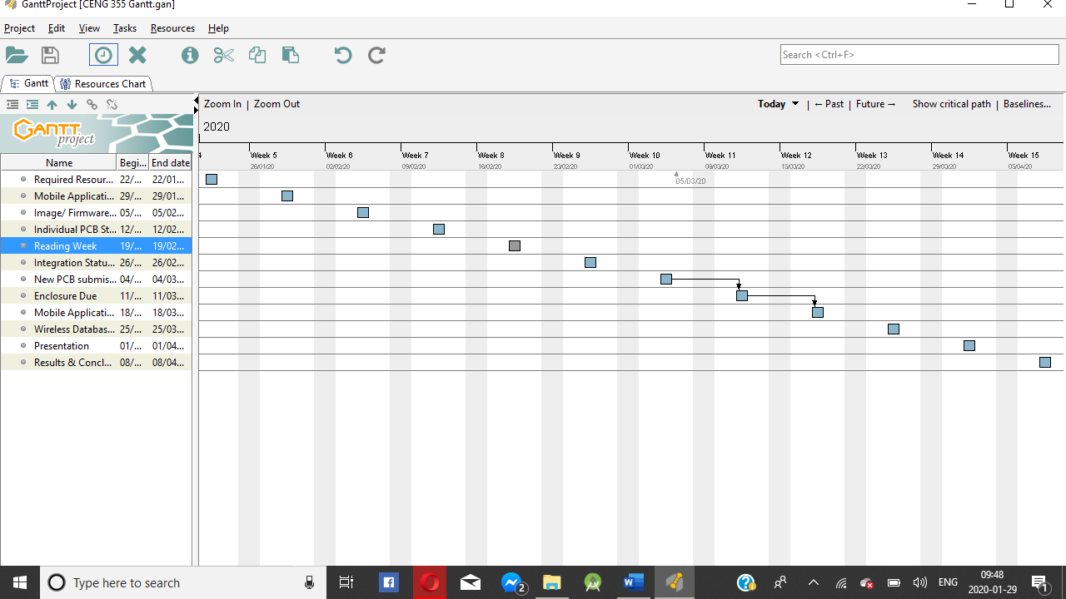

Figure 0. Gantt Chart for project implementation.

## 3.2 Development Platform

### 3.2.1 Mobile Application

We have created a Mobile Application for our project using Android Studio with a simple user interface that allows parents to control the hardware with a few clicks. In the first phase of the mobile app development, we implemented the splash screen with shows up at the starting of the app for about 3 seconds. To implement the splash screen into our app, we defined it in styles.xml file and made changes to the manifest file so that it opens before the main activity, for about 3 seconds. Next, we have the login screen interface which allows registered users to login to the app, as well as create a new account and help them recover it. To implement the login, we first designed the User interface of the screen and then added functionality to the buttons, like getting to another activity through intents, or simply exiting the app by clicking on the Quit app button. Furthermore, we connected our app to Firebase in order to verify the credentials of our user in the login process. To achieve the credential verification process, we included a few methods in our main program provided by Firebase. We also used intents to start an activity of a different class named as Signup to create new users and add them to the online database. We used the same process as well for users that forgot their credentials. We also included a special class to retrieve all the user information from the specific activities and push the data to Firebase, as well as to match the credentials with the ones entered by the user. During the second phase of the software development we worked on a menu page that contains our own individual pages for the three sensors. We designed the UI for the menu and added functionality to the buttons to navigate to our individual pages. Manshur worked on the temperature and humidity page of the app (Figure 1). His page displays the current temperature and humidity readings from the sensor as well as two graphs. He has implemented the graphs through existing android libraries that record the temperature and humidity trends over a week and fetch the information and display it to the user in the form of graphs. Deval has worked on the Light/Luminosity sensor section of the app. He is working on controlling the WS2812B Led ring from the app. At the moment, he has implemented some options in the app for the ring such as turning the Led manually, adjusting brightness, and displaying the light levels from his Tsl2591 sensor. In another activity, he has implemented a color wheel that allows parents to pick a color suitable for their infants to light up their room at night. The color wheel works by swiping through the wheel and customizing the RGB values for the Neopixel ring. The RGB selection is displayed at the bottom of the screen and at the moment it changes the background of the screen. By clicking on the center of the wheel the color settings and the background screen defaults to a white. We have also added the RGB values to be included in the database. We also have a page for the microphone sensor which is supposed to play the wav files that is recorded by the hardware.in addition to that we have enabled Bluetooth features i.e. is able to switch on/off, search for devices and connect to available devices. We also made a contact and feedback page that allows the user to type feedbacks of the app and address any problems that they have in it. We send this data directly to Firebase at the moment. The future of our software app is to integrate it with the three sensors that we have and get the readings from them directly instead of relying on readings from the cloud database.

General Screenshots from the working Application:

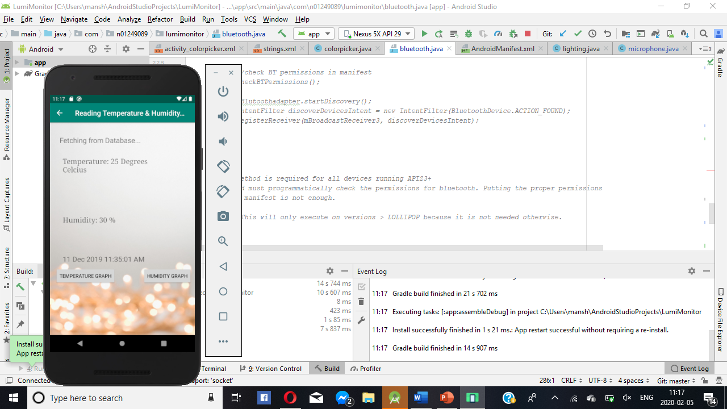 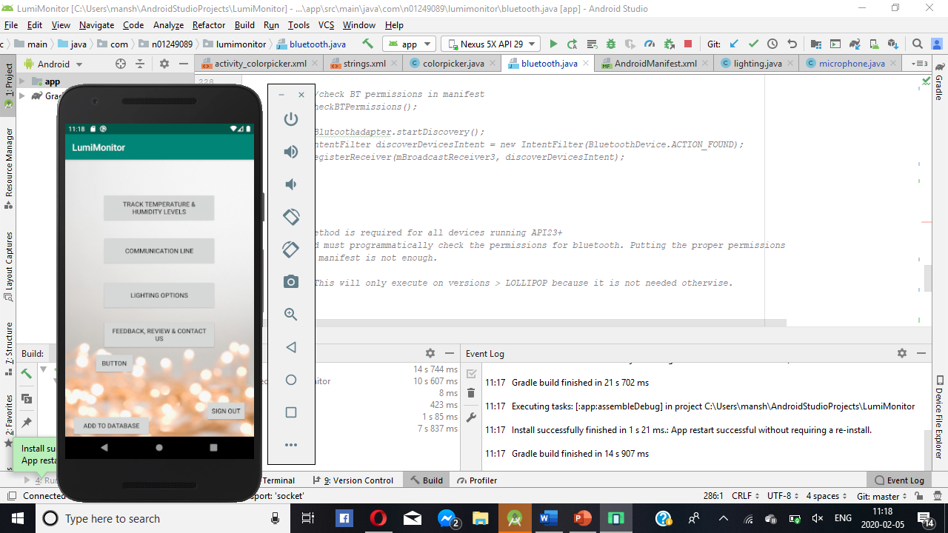

Figure 1. By Android Studio – App Demo on Emulator

Data Visualization with reading from firebase Database (Graph with timestamps):

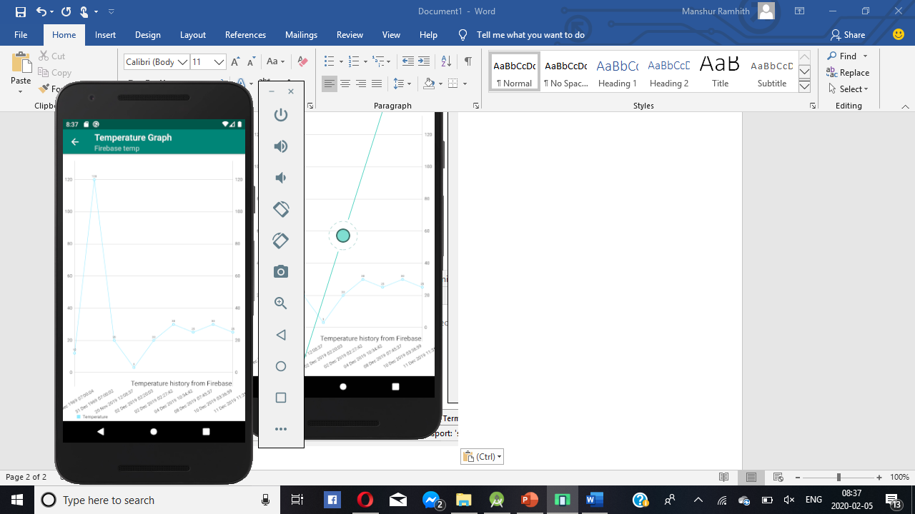 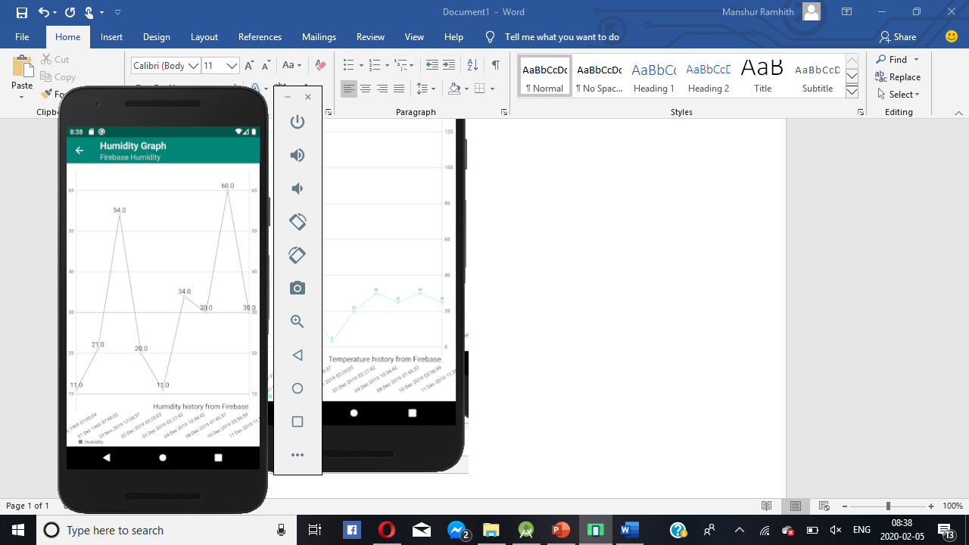

Figure 2. By Android Studio – Data Visualization on Emulator.

### 3.2.2 Image/firmware

Making an image/firmware is the first step to putting the development platform in use. Firmware is a specific class of computer software that provides low level control for the device’s specific hardware. It can either provide a standardized operating environment for the devices more complex software (allowing for more hardware independence) or for less complex devices, it acts as the devices complete operating system, performing all control, monitoring and manipulation functions. Manshur and Abdirashid both used raspberry pi 3 B+ and Deval used Raspberry PI 4. We all chose to make an image of Raspbian for the pi’s. First, we had to format the pi’s SD card as MS-DOS (FAT) on mac and FAT32 on Windows using SD card formatter software that we downloaded form the internet. This process took almost half an hour to one hour for every single card depending on the card size. The second step is installing operating system for the development platform. We downloaded NOOBs (Operating system installer) which contains the Raspbian image from www.raspberypi.org. Next, we unzipped the NOOBs zip files and paste the uncompressed img files inside noobs to the SD card. Next, we insert the card in the PI and powered it up. After the pi goes on, it prompts the user to install the Raspbian operating system. With a successful install the raspberry pi boots with Raspbian operating system. After having the operating system on the raspberry pi, the following step is installing firmware. To install this under Raspbian operating system, “sudo apt-get install rpi-update” is the command that is run on the rpi terminal. Next, to update the firmware, you run “sudo rpi-update” on the terminal. This should not take more than half an hour depending on your internet connection. After the firmware has been successfully updated, you’ll need to reboot and load the new firmware. We used “sudo reboot” command to safely reboot the pi from the terminal. To verify the firmware version, we had installed on our raspberry pi’s, we run the command “/opt/vc/bin/vcgencmd version” on the terminal. This displays date, time, copyright and the firmware version. We further intend to backup the zip file of the image into a USB drive for safety purpose. At first, we hardwired the raspberry pi’s to a monitor for connection by ethernet cable and HDMI cable. Unlike last semester, this course requires remote access to the pi from another machine. We have done this in two different ways. Manshur and Abdirashid both opted to use windows remote desktop connection whereas Deval chose to work with Virtual Network Computing (VNC) viewer to mirror his raspberry pi. For the final prototype development platform, we intend on using the wired remote desktop connection as it is more reliable and more familiar to us since we used it in a previous course. Moreover, the process of how we got Remote desktop connection to work can be found on the blog of our repository under the Power Up section.

### 3.2.3 Breadboard/Independent PCBs

Our current hardware currently is made up of three different PCBs. The first PCB contains the temperature and humidity sensor known as DHT22, the second holds the microphone sensor SPH0645 and the final one comprises of the TSL2591 as well as the Neopixel LED strip. In this section, I am going to explain how each one of us got started on our individual hardware and I am also going to go over how we connected as well as tested our initial connections and later translated the working connection onto a Printed Circuit Board. First of all, we all started to design our circuit connections on a designing software called Fritzing. This piece of software allowed us to visualize the connection that you want to test and at a later stage of your development Fritzing actually allows you to convert whatever breadboarded design you are working with to PCB files. Afterwards we had to convert the design to the Gerber files, which is the file type recognized by the printer in the prototype Lab (J232) which uses a special printer to print PCBs on campus at Humber. After searching for our particular sensors on Fritzing and designing the circuit and connected it accordingly on an actual breadboard, we converted the schematics to the respective PCB files and sent the Gerber files to the prototype lab. The only thing left to do at this stage was soldering, which was done for the most part during class time in the Hardware Productions class we took in the previous semester. The first PCB that I am going to talk about is the one containing the DHT22 temperature and humidity sensor. Based on my design on Fritzing I was able to determine the following connections:

1. 3.3v is connected to VCC on the Raspberry Pi and pin 1 of the DHT22

2. GND is connected to pin 4 of the DHT22 and pin 7 of the Raspberry Pi

3. Data Line is connected to pin 2 of the DHT22 and pin 6 of the Raspberry Pi

4. 10K Ohm resistor in between pin 2(Data Line) & pin 1(Power) of the DHT22.

It is important to note that the same connection pattern has to be followed the whole designing process and actually making the prototype. As you can see in Figure 3 – Breadboard Design for DHT22 and Figure 4 - PCB design for DHT22, the breadboard and PCB design connections follow that of the schematic but has also been simplified. For the Microphone sensor SPH0645, the connection is as follows:

1. Mic 3V - Pi 3.3v

2. Mic GND - Pi GND

3. Mic SEL - Pi GND (this is used for channel selection. Connect to 3.3 or GND)

4. Mic BCLK - BCM 18 (pin 12 of the Raspberry Pi)

5. Mic LRCL - BCM 19 (pin 35 of the Raspberry Pi)

6. Mic DOUT - BCM 20 (pin 38 of the Raspberry Pi)

The schematic is also shown in Figure 5 - Schematic for SPH0645. Figure 6 - PCB Design for SPH0645 shows the PCB design file. For our final PCB, which contained the TSL2591 & the Neopixel Strip, the following connection scheme was used:

1. The 3.3v pin from the Pi connects to the Vin of the sensor and provides it with power.
2. Both the GND connections for the Pi and the sensor are connected together on the PCB.
3. The Pi Synchronized clock pin connects to the sensor SCK pin. The Pi SDA pin is connected with the sensor SDA pin.
4. SN74AHCT125 3.3v to 5v level converter chip. The Pi's GPIO 18 pin is connected to the chip’s 1A pin.
5. The pin 1Y on the chip connects to the Din pin of the Neopixel to provide it the appropriate 5v data from the Pi.
6. The GND of the power supply is connected to the one of the SN74AHCT125 chip along with pin 10E.
7. The power supply GND is also connected to the Pi and Neopixel GND.
8. The power supply's 5v is connected to the converter chip's VCC along with the Neopixel 5v power input.

Figure 9,Figure 10 & Figure 11 show the final breadboarded connections whereas Figure 12,Figure 13 & Figure 14 show the final Soldered Printed circuit boards for all three individual PCBs.

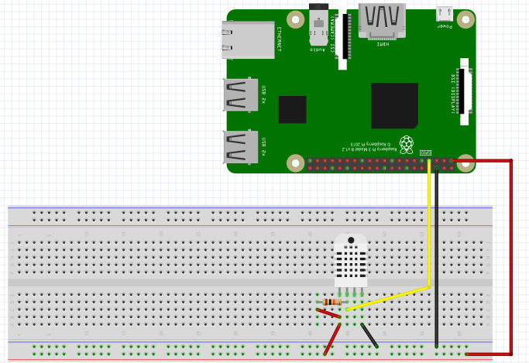

Figure – Breadboard Design for DHT22

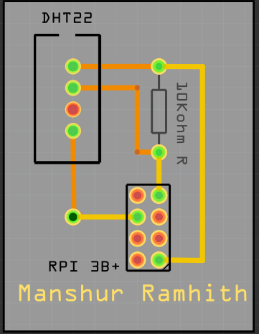

Figure - PCB design for DHT22

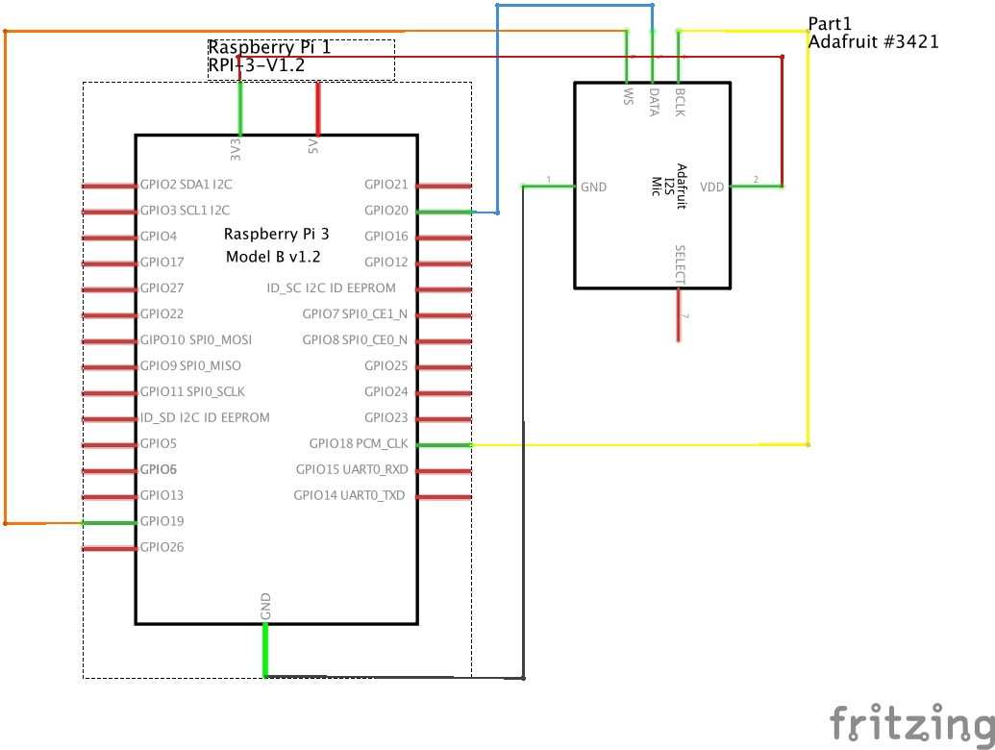

Figure - Schematic for SPH0645

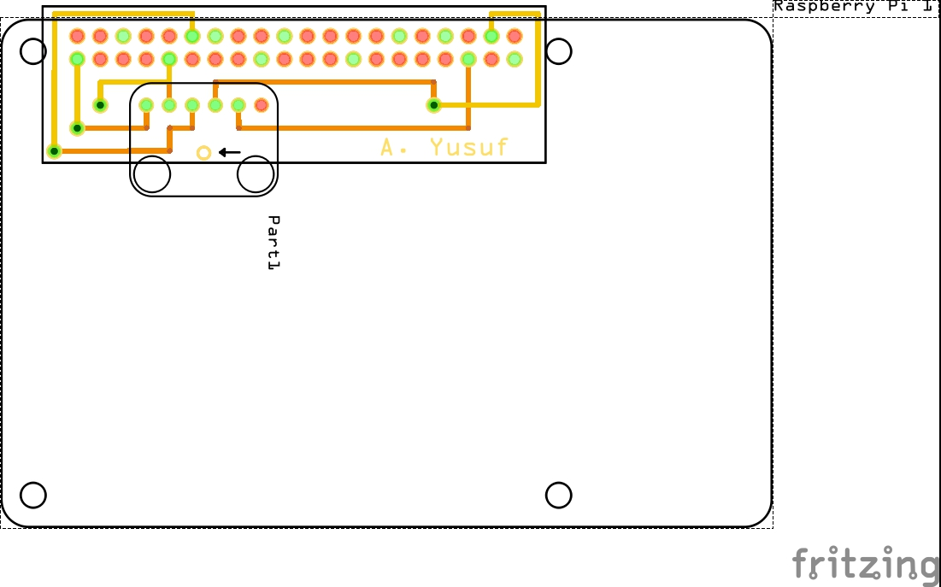

Figure - PCB Design for SPH0645

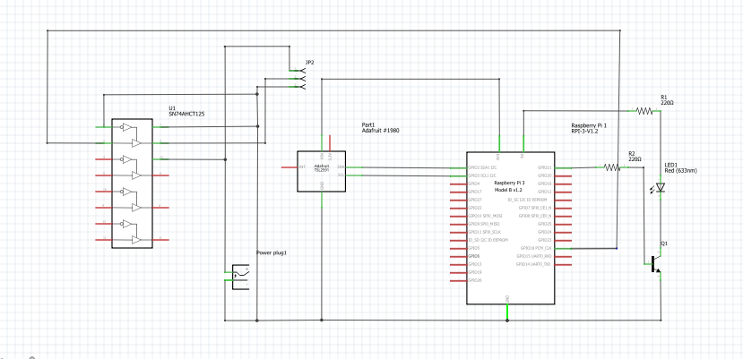

Figure - Schematic Design for TSL2591 and Neopixel Strip

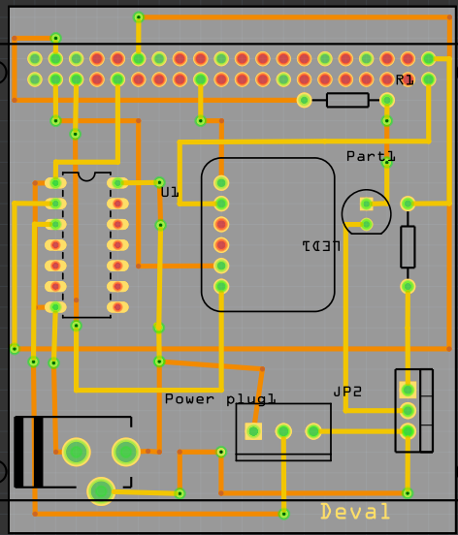

Figure - PCB Design for TSL2591 and Neopixel Strip

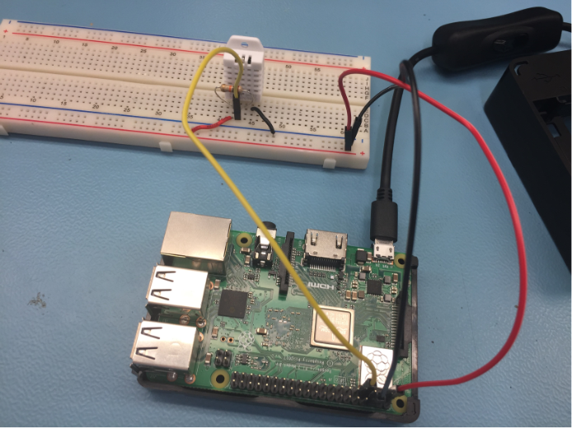

Figure - Final Breadboard Connection for DHT22

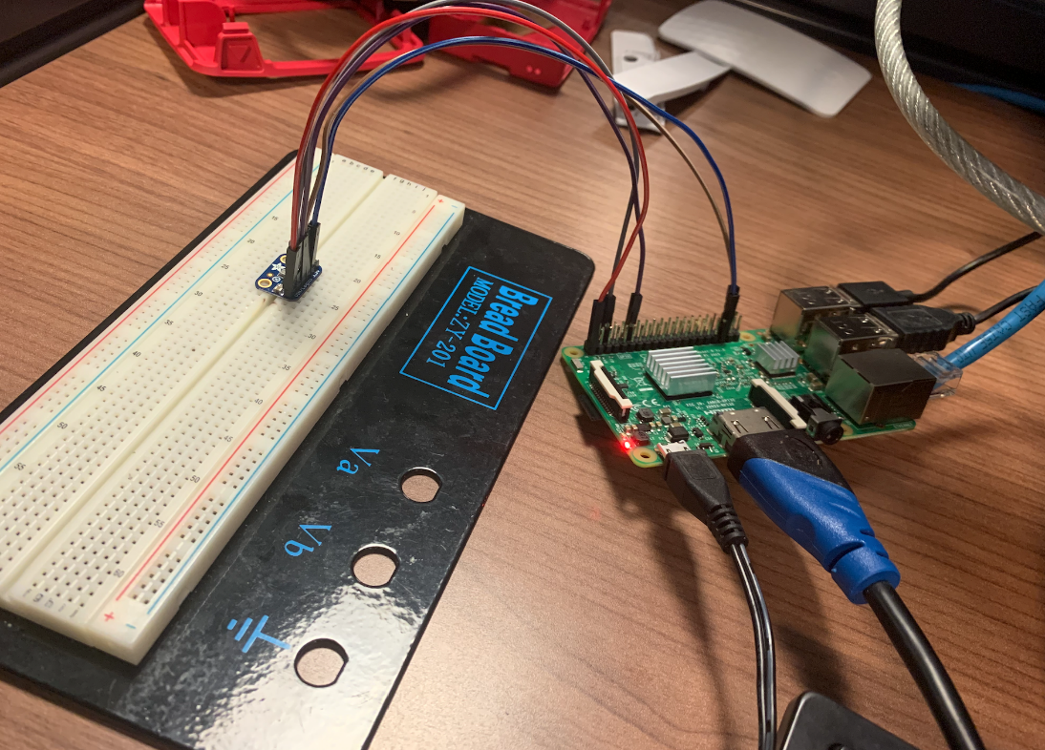

Figure - Final Breadboard Connection for SPH0645

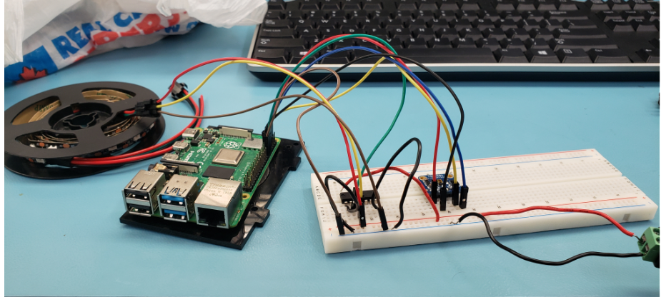

Figure - Breadboarded Connection for TSL2591 & Neopixel Strip

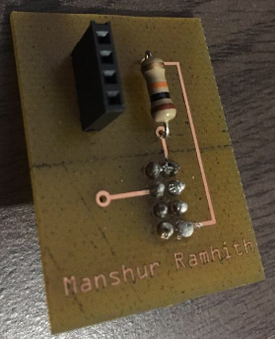

Figure - PCB for DHT22

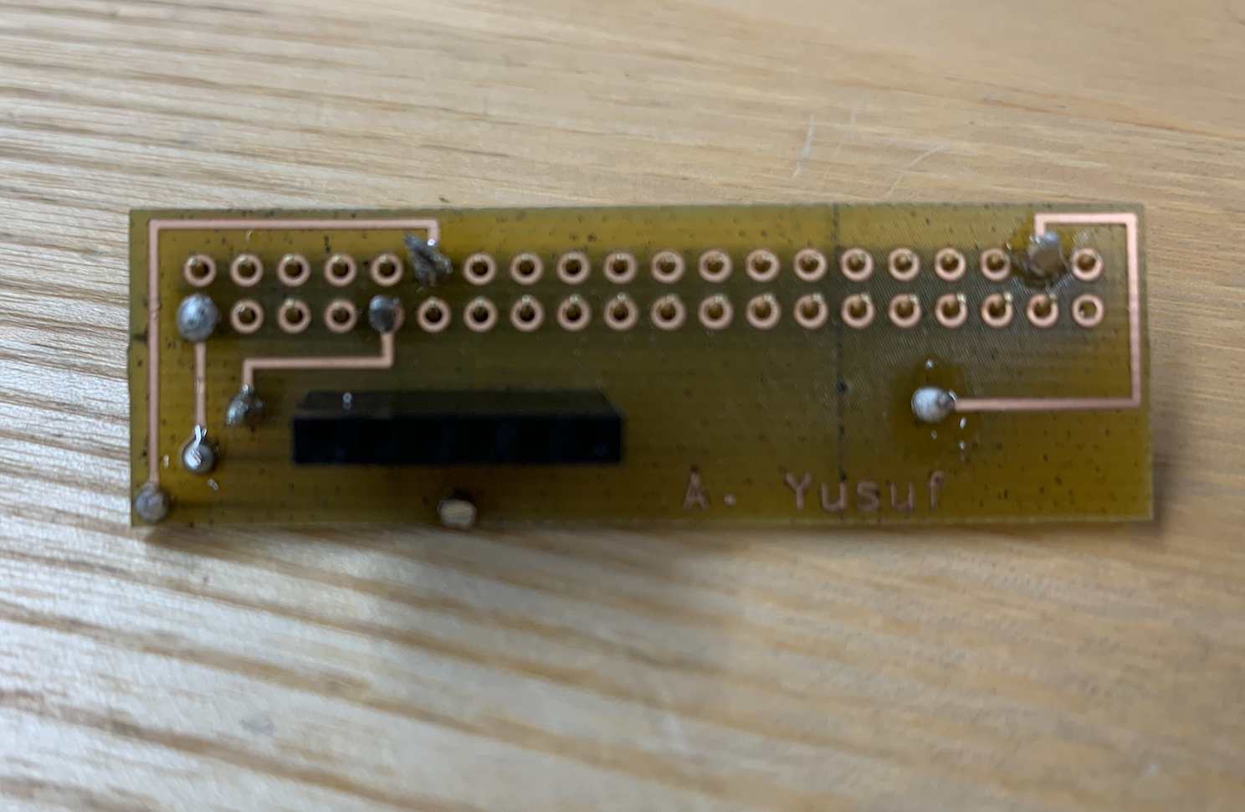

Figure - PCB for SPH0645

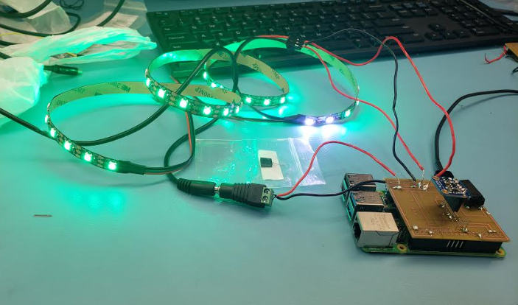

Figure - PCB for TSL2591 & Neopixel Strip

### 3.2.4 Printed Circuit Board

Demo

/1 Hardware present?

/1 PCB Complete and correct

/1 PCB Soldered wire visible but trim, no holes or vacancies

/1 PCB Tested with multimeter

/1 PCB Powered up

Figure Complete and soldered PCB

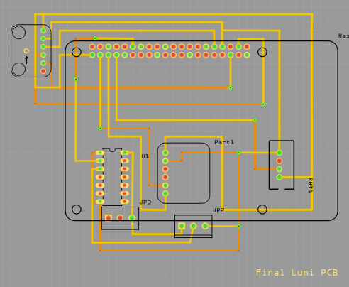

Figure Final PCB design Lumi

How did you build your Prototype: PCB?

For our final PCB, we have tested the PCB using a multimeter in order to detect any faults; we are pleased to report that all our sensors work accordingly and that the PCB has no faults or shorts across it. The following 15 steps describe how we have achieved the connection for this printed circuit board:

1. 3.3v is connected to VCC on the Raspberry Pi and pin 1 of the DHT22

2. GND is connected to pin 4 of the DHT22 and pin 7 of the Raspberry Pi

3. Data Line is connected to pin 2 of the DHT22 and pin 6 of the Raspberry Pi

4. 10K Ohm resistor in between pin 2(Data Line) & pin 1(Power) of the DHT22.

5. Mic 3V - Pi 3.3v (Using same 3.3 V (pin 1) as the DHT22)

6. Mic GND - Pi GND (Common GND as DHT22 and TSL2591)

7. Mic SEL - Pi GND (this is used for channel selection. Connect to 3.3 or GND)

8. Mic BCLK - BCM 18 (pin 12 of the Raspberry Pi)

9. Mic LRCL - BCM 19 (pin 35 of the Raspberry Pi)

10. Mic DOUT - BCM 20 (pin 38 of the Raspberry Pi)

11. The 3.3v pin from the Pi connects to the Vin of the sensor and provides it with power.

12. Both the GND connections for the Pi and the sensor are connected together on the PCB.

13. The Pi Synchronized clock pin connects to the sensor SCK pin. The Pi SDA pin is connected with the sensor SDA pin.

14. SN74AHCT125 3.3v to 5v level converter chip. The Pi's GPIO 18 pin is connected to the chip’s 1A pin.

15. The pin 1Y on the chip connects to the Din pin of the Neopixel to provide it the appropriate 5v data from the Pi.

16. The GND of the power supply is connected to the one of the SN74AHCT125 chip along with pin 10E.

17. The power supply GND is also connected to the Pi and Neopixel GND.

18. The power supply's 5v is connected to the converter chip's VCC along with the Neopixel 5v power input.

### 3.2.5 Enclosure

Demo

/1 Hardware present?

/1 Case encloses development platform and custom PCB.

/1 Appropriate parts securely attached.

/1 Appropriate parts accessible.

/1 Design file in repository, photo in report.

How did you build your Prototype: Case?

The case would have consisted of the 3D printed top as well as a circular acrylic base under normal circumstances. The 3D printed part was sent to the prototype lab for printing, but unfortunately, we were unable to pick it up from them.

## 3.3 Integration

Demo

/1 Hardware present?

/1 Data sent by hardware

/1 Data retrieved by mobile application

/1 Action initiated by mobile application

/1 Action received by hardware

Report

/1 Enterprise wireless connectivity (250)

/1 Database configuration (250 words)

/1 Security considerations (500 words)

/1 Unit testing (900 words)

/1 Production testing (100 words)

### 3.3.1 Enterprise Wireless Connectivity

How did you make a Database accessible by both your Prototype and Mobile Application?

### 3.3.2 Database Configuration

### 3.3.3 Security

### 3.3.4 Testing

Unit testing and Production testing.

# 4.0 Results and Discussions

Is your prototype perfect? What did you learn?

# 5.0 Conclusions

If you were making 1000 of these.

Report

/1 Hardware present?

/1 Checklist truthful

/1 Valid Comments

/1 Results and Discussion (500 words)

/1 Conclusion

# 6.0 References

Bosch Sensortec. (2019, July). *BME680 - Datasheet.* Retrieved from Robert Bosch GmbH: https://ae-bst.resource.bosch.com/media/_tech/media/datasheets/BST-BME680-DS001.pdf

Kinsella, J. (2019). Five trends predicted for the cloud industry in 2019. *Software World*, 50(1), 11.

Media, O. (2019). *O'Reilly artificial intelligence conference 2019 - San Jose, California.* California: O'Reilly Media, Inc.

OACETT. (2017, March). *I need to Complete a Technology Report*. Retrieved from The Ontario Association of Certified Engineering Technicians and Technologists: https://www.oacett.org/Membership/Technology-Report-and-Seminar

Robuck, M. (2018, 11). AWS goes deep and wide with machine learning services and capabilities. *Fierceinstaller*.

# 7.0 Appendix

Integrated Code for DHT22 & TSL2591

#TSL2591 imports

import time

import board

import busio

import neopixel

import adafruit_tsl2591

#Imports for DHT22_sensor & Delay

import Adafruit_DHT

from time import sleep

#Pin Assignment for TSL2591

i2c = busio.I2C(board.SCL,board.SDA)

sensor = adafruit_tsl2591.TSL2591(i2c)

#Assigning pin number and sensor type

DHT_SENSOR = Adafruit_DHT.DHT22

DHT_PIN = 4

#Main

print(" Starting Temperature & Humidity Sensing...")

print("Pulling Readings every 3 seconds")

while True:

#3 seconds delay in between getting readings

sleep(3)

humidity, temperature = Adafruit_DHT.read_retry(DHT_SENSOR, DHT_PIN)

if humidity is not None and temperature is not None:

print("Temp={0:0.1f}*C Humidity={1:0.1f}%".format(temperature, humidity))

else:

print("Failed to retrieve data from Sensor")

# You can optionally change the gain and integration time:

#sensor.gain = adafruit_tsl2591.GAIN_LOW (1x gain)

#sensor.gain = adafruit_tsl2591.GAIN_MED (25x gain, the default)

#sensor.gain = adafruit_tsl2591.GAIN_HIGH (428x gain)

#sensor.gain = adafruit_tsl2591.GAIN_MAX (9876x gain)

#sensor.integration_time = adafruit_tsl2591.INTEGRATIONTIME_100MS (100ms, default)

#sensor.integration_time = adafruit_tsl2591.INTEGRATIONTIME_200MS (200ms)

#sensor.integration_time = adafruit_tsl2591.INTEGRATIONTIME_300MS (300ms)

#sensor.integration_time = adafruit_tsl2591.INTEGRATIONTIME_400MS (400ms)

#sensor.integration_time = adafruit_tsl2591.INTEGRATIONTIME_500MS (500ms)

#sensor.integration_time = adafruit_tsl2591.INTEGRATIONTIME_600MS (600ms)

# Read the total lux, IR, and visible light levels and print it every second.

while True:

# Read and calculate the light level in lux.

lux = sensor.lux

print('Total light: {0}lux'.format(lux))

# You can also read the raw infrared and visible light levels.

# These are unsigned, the higher the number the more light of that type.

# There are no units like lux.

# Infrared levels range from 0-65535 (16-bit)

infrared = sensor.infrared

print('Infrared light: {0}'.format(infrared))

# Visible-only levels range from 0-2147483647 (32-bit)

visible = sensor.visible

print('Visible light: {0}'.format(visible))

if(visible<200080000):

pixels=neopixel.NeoPixel(board.D18,60)

pixels.fill((255,0,255))

# elif(visible == 1):

# pixels=neopixel.NeoPixel(board.D18,60)

# pixels.fill((0,5,0))

# Full spectrum (visible + IR) also range from 0-2147483647 (32-bit)

full_spectrum = sensor.full_spectrum

print('Full spectrum(IR + visible) light: {0}'.format(full_spectrum))

time.sleep(1.0)

## 7.1 Firmware code

Demo

/1 Hardware present?

/3 Code runs concurrently for all sensors/effectors

/1 Project repository contains integrated code

Status

/1 Memo including updates

/1 Financial update

/1 Progress update

/1 Modified Code Files in Appendix

/1 Link to Complete Code in Repository

## 7.2 Application code

Demo

/1 Hardware present?

/1 Memo by student A

/1 Login activity

/1 Data visualization activity

/1 Action control activity

Report

/1 Login activity

/1 Data visualization activity

/1 Action control activity

/1 Modified Code Files in Appendix

/1 Link to Complete Code in Repository